
National College of Computer Studies
Paknajol, Kathmandu

Report on Currency Converter

Submitted by: Suraj Timsina Submitted to:
Programme: BSc. CSIT, 1st Semester Sumit Ghising
Section: B C Programming Lecturer
Roll No: 23
Email: surajtimsina321@gmail.com

Declaration
I hereby declare that the project work entitled “Currency Converter” submitted to Institute of Science and Technology, Tribhuvan University, Kathmandu. National College of Computer Studies, Kathmandu, is for the degree is submitted in partial fulfillment of requirements for the degree of Bachelor of Science in Computer Science and Information Technology (BSc.CSIT). This report contains all the original research and analysis with some information taken from other resources which are properly cited. This project work has not been submitted to any other university or institution for the award of any degree or diploma.

……………………………………………
Suraj Timsina
Date: August 2023

Acknowledgement

This report is my assignment as a partial fulfillment of project work course for the requirement of Bachelor of Science in Computer Science and Information Technology (BSc.CSIT). I have taken this opportunity to express my respect and gratitude to my respected teacher Mr. Sumit Ghising for their valuable guidance in making this project a reality. I am thankful for their constant support and encouragement and valuable guidance and encouragement throughout this project completion period. I am also thankful to the lab teacher Kajol Ramtel for her help during the completion of the project. I would like to present my teachers gratitude for their guidance, good advice and honest reviews in this entire project session. Project has been completed under the intensive and genuine guidance of National College of Computer Studies.

Suraj Timsina
National College of Computer Studies
Date: August 2023

Abstract
My project on the topic “Currency Converter” is a project on C which allows the user to convert any amount of currencies to Nepalese currency. This small-scale project aims to provide an intuitive interface for users to input foreign currency amounts and instantly obtain the equivalent values in Nepali Rupees. The user has to give the number in which they want to convert their currency and the amount of currency they want to convert and the program displays the required output by doing its calculation. This program is very useful and effortless to use. Mostly tourists who came to visit Nepal use this program. This program can be used again and again as long as the user wants it.

Table of Contents
1. Introduction 1
2. Objective 1
3. LITERATURE REVIEW 1
4. METHODOLOGY 2
5. EXPERIMENT RESULT AND EXPECTED OUTCOME 2
6. SYSTEM IMPLEMENTATION 2
6.1. The Hardware used 2
6.2. The Software used 2
7. SYSTEM DESIGN AND DEVELOPMENT 2
7.1. MY SOURCE CODE 3
7.2. OUTPUT 5
8. Conclusion 6
9. User Manual 6
References 7

List of Figures
Figure 1: get functions for read amount 3
Figure 2: Convert function for convert currency 3
Figure 3: List of currency 4
Figure 4: switch case 4
Figure 5: jump statement goto 5
Figure 6: Output 1 5
Figure 7: Output 2 6

Abbreviations
i.e. - That is
IDE - Integrated Development Environment
VS - Visual Studio

Introduction
C is a general-purpose programming language created by Dennis Ritchie at the Bell Laboratories in 1972. It is a very popular language, despite being old. C is strongly associated with UNIX, as it was developed to write the UNIX operating system. The currency converter is a simple application written in the C programming language that allows users to convert various foreign currencies to Nepalese Rupee. It is useful tool which give the value of certain amount of one currency to be converted into a Nepali currency based on current exchange rates. Currency converter is generally useful to tourists who came to visit Nepal. This project has 21 different foreign countries currency i.e. Indian Rupee, US Dollar, Euro, British Pound Sterling, Swiss Franc, Australian Dollar, Canadian Dollar, Singapore Dollar, Japanese Yen, Chinese Yuan, Saudi Arabian Riyal, Qatari Riyal, Thai Baht, UAE Dirham, Malaysian Ringgit, South Korean Won, Swedish Krona, Danish Krone, Hong Kong Dollar, Kuwaiti Dinar and Bahrain Dinar which can be converted into Nepalese Rupee. It is useful tool which give the value of certain amount of one currency to be converted into a Nepalese currency. [1]

Objective
The primary objectives of this project are as follows:
- Create a User-Friendly Interface: Develop a user interface that accepts the amount in a foreign currency and displays the equivalent amount in Nepalese Rupee.
- Support Multiple Currencies: Design the program to handle a variety of foreign currencies and their exchange rates.
- Accurate Conversion: Ensure accurate currency conversion by utilizing up-to-date exchange rates.
- Error Handling: Implement error-handling mechanisms to handle invalid inputs and prevent program crashes.
- Efficiency: Write efficient code that delivers quick results, even with frequent currency conversions.

LITERATURE REVIEW
There has been several literature review and documentation regarding the work done in currency converter. Many programmers have tried to recreate this currency converter adding their own version to it. There were several creators who tried to create it. They used various functions and loops to create the currency converter. [2]

METHODOLOGY
- Designing:
- Designing algorithm and flowchart.
b) Coding:
- Creating get and Convert functions that read currencies and convert it.
- Displaying all the list of the currency that can be converted.
- Ask the user for input(conversion selection).
- Using switch case to start selected conversion.
- Ask the user for input(amount).
- Display the result of converted currency.
- Ask the user if they want to use it again.

EXPERIMENT RESULT AND EXPECTED OUTCOME
We expect to convert the currency of one country to Nepalese of any amount as per the user input. We also expect that the program is effortless to use and any amount of currency can be converted into the Nepalese currency. Hence, we expect a simple and effective currency converter.

SYSTEM IMPLEMENTATION

The Hardware used
The implementation of a Currency Converter using C can be done on any hardware that supports the C programming language, including personal computers, laptops, and servers.

The Software used
The software used to develop this program is DEV C++ and its frameworks. There was no graphics used. Some popular C IDEs include Visual Studio, VS code, Code::Blocks, and Eclipse.

SYSTEM DESIGN AND DEVELOPMENT
For data storage, the amount of storage used to store the program's data, including any variables used by the program is the size of the data storage, that will depend on the size and number of the variables and files used by the program.

MY SOURCE CODE

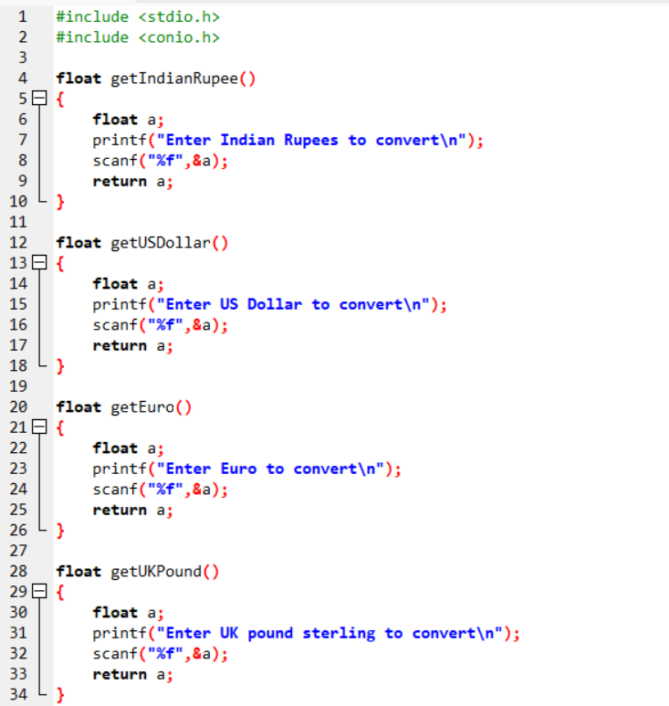
Figure 1: get functions for read amount

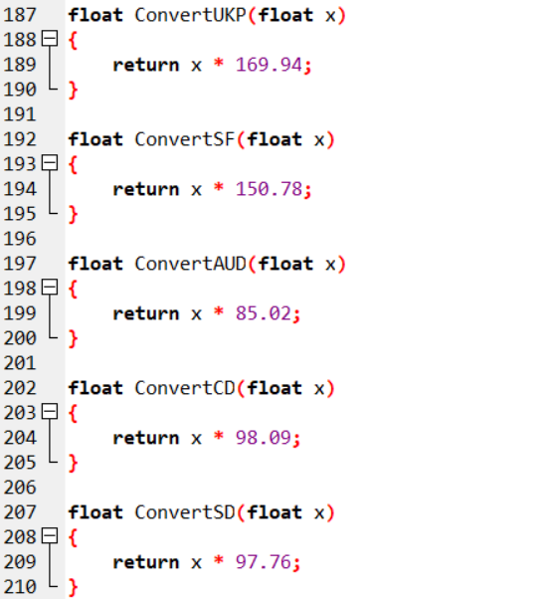
Figure 2: Convert function for convert currency
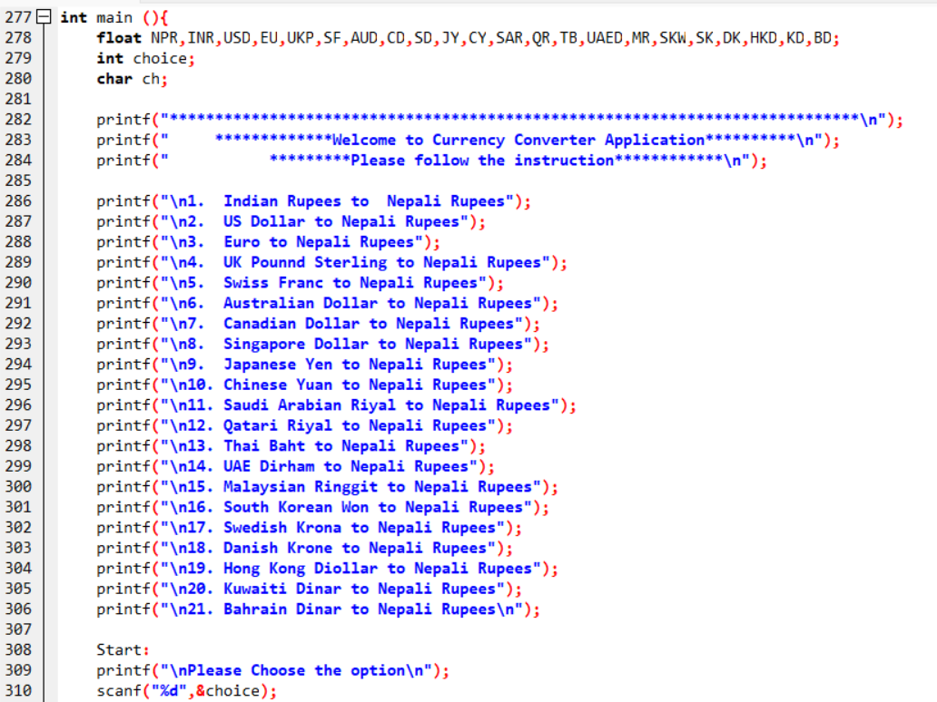
Figure 3: List of currency

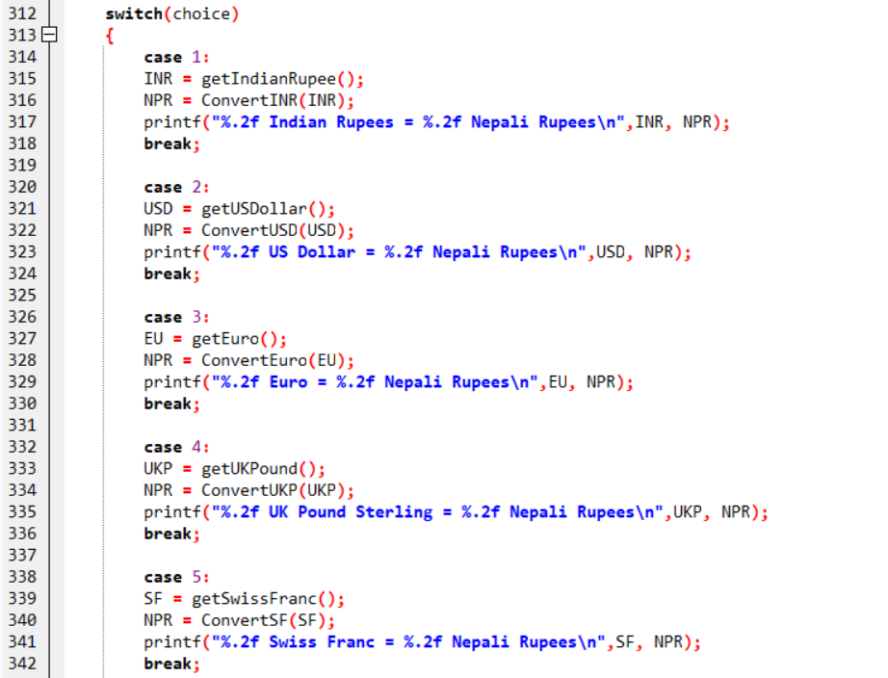
Figure 4: switch case

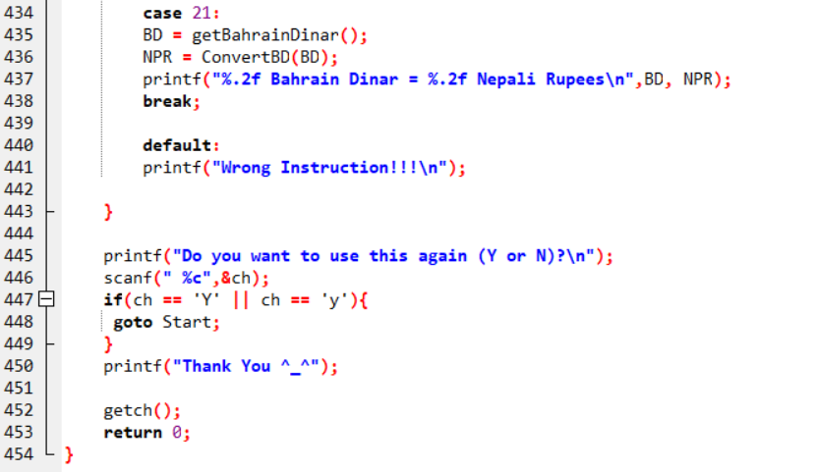
Figure 5: jump statement goto

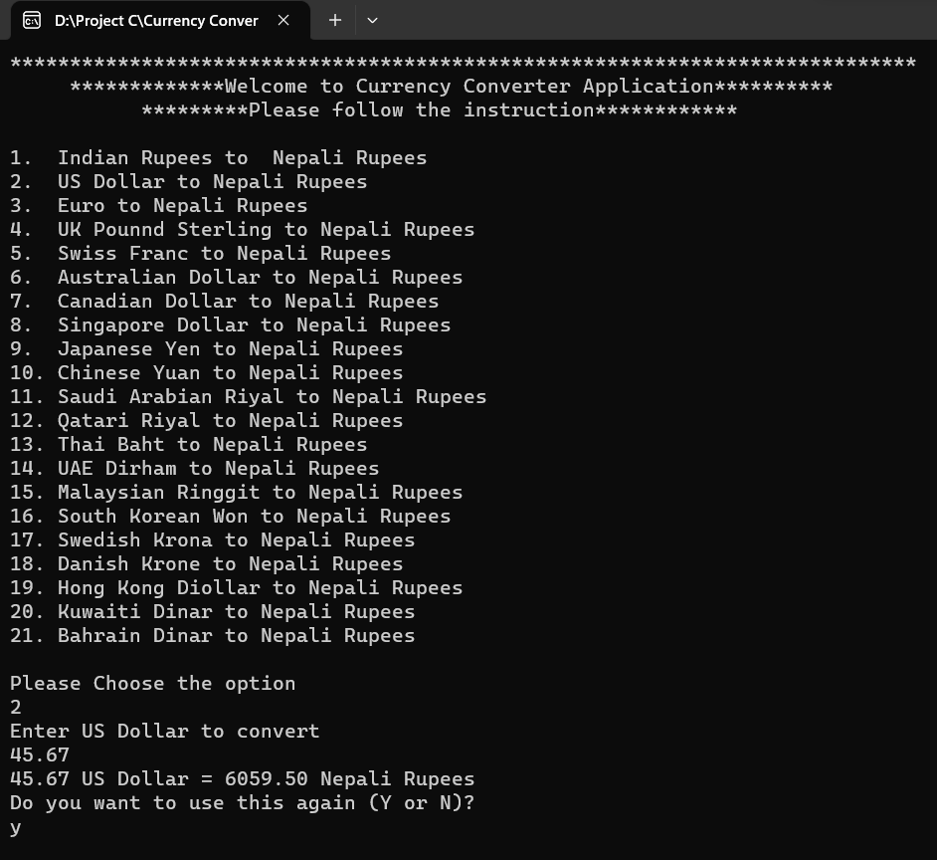
OUTPUT
Figure 6: Output 1

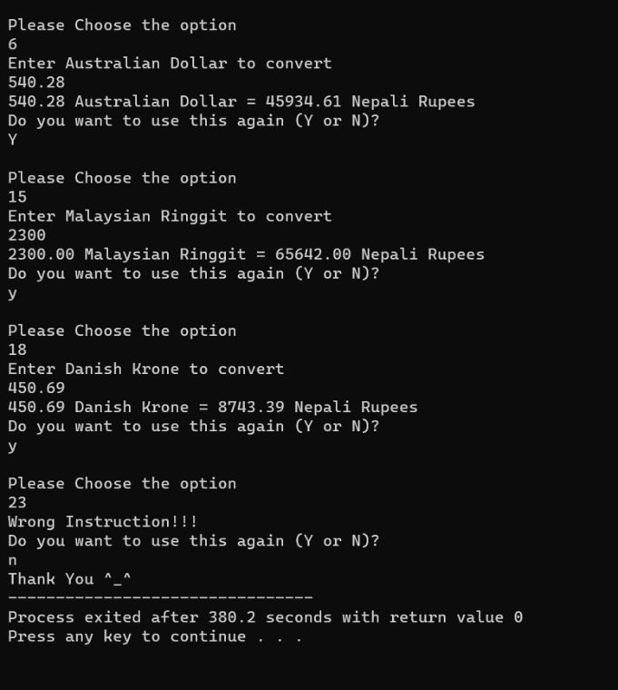

Figure 7: Output 2

Conclusion
The Currency Converter is a simple yet functional project that demonstrates the principles of user input, conditional statements, and function usage in the C programming language. While the application achieves its goal, there is room for improvement in terms of code optimization and maintainability. This project serves as a starting point for learning more about programming and developing more sophisticated applications in C.

User Manual
The currency converter is very easy to use and can be used by anyone who has to convert their currencies. Here are some instructions on how to run this program:
- Run the application using a C compiler or IDE.
- Follow the on-screen instructions to select the desired currency conversion.
- Input the amount in the chosen foreign currency.
- The application will display the equivalent amount in Nepali Rupees.
- You can choose to perform another conversion or exit the application.
- If you want to use it again, press ‘y’ to use it again.

References

[1] | "Wikipedia," [Online]. Available: https://en.wikipedia.org/wiki/C_(programming_language).
[2] | [Online]. Available: http://studentsrepo.um.edu.my/3128/5/Chapter_2.pdf.

